A WEEKEND IN LONDON

Listen and find information about the museum they are visiting next weekend.

Teenager’s name | Notes
………………………... | Personal details :  The museum :
………………………... | Personal details :  The museum :
………………………... | Personal details :  The museum :
………………………... | Personal details :  The museum :

Write the name of each teenager under the corresponding museum :

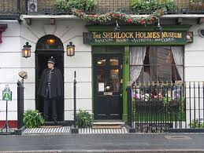 | 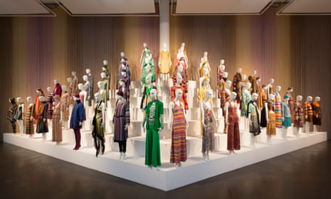
…………………………… | …………………………… | …………………………… | ……………………………

Let’s recap your notes :

What about you ? What museum would you like to visit ?Justify your answers.

Listen and find information about the museum they are visiting next weekend.

Teenager’s name | Notes
ALEX | Personal details :  Fond of detective stories / lots of mystery books at home  The museum : you can learn everything about a very famous detecive
JESSICA | Personal details :  Really interested in nature and animals  The museum :  You can see a huge dinosaur gallery / you can explore the universe
BRATT | Personal details :  A creative person / he’s into art  The museum :  All the paintings at this museum are great and a source of inspiration
LINZY | Personal details :  An art and fashion lover.  The museum :  There are lots of extraordinary clothes and jewels

Write the name of each teenager under the corresponding museum :

ALEX | LINZY | JESSICA | BRATT

Let’s recap your notes :

