LISTENING

Pupils of the Content Primary and Infant School in the Jamaican countryside.

Watch the video and circle the places you see :
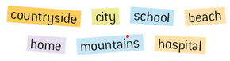
Complete the card about Leanna :
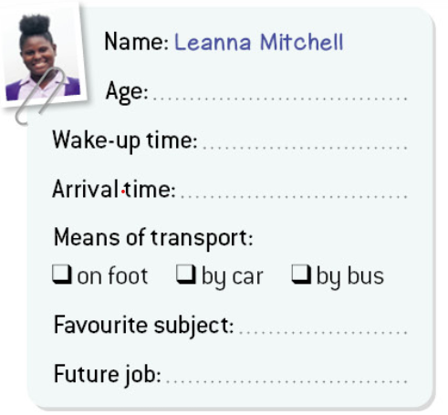
Use the information from the chart and write about Leanna’s routine :
…………………………………………………………………………………………………………………………………………………………………………………………………………………………………………………………………………………………………………………………………………………………………………………………………………………………………………………………………………………………………………………………………………………………………………………………………………………………………………………………………………………………………………………………………………………………………………………………………………………………………………………………………………………………………………….
GRAMMAR :

