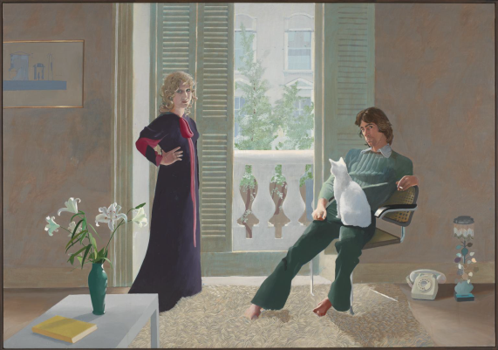 | 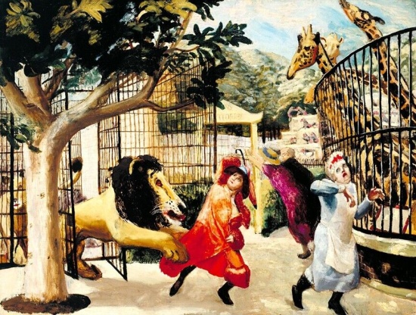
David Hockney, ‘Mr and Mrs Clark and Percy’, 1971, Tate Modern. | Carel Weight, ‘Allegro Strepitoso’, 1932, Tate Modern.
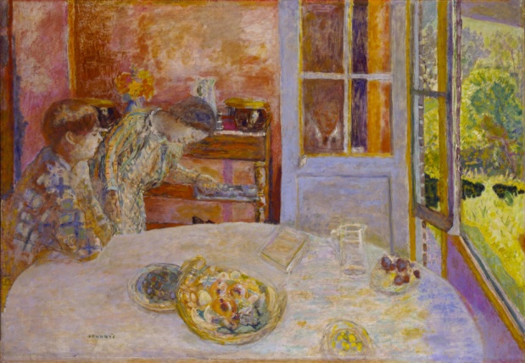 | 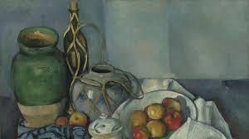
Pierre Bonnard, ‘The Living Room’, 1925, Tate Modern. | Paul Cézanne, ‘Still Life With Apples’, 1894, Tate Modern.

